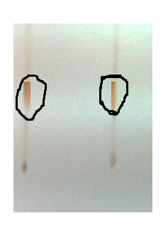
Ethanol: Chloroform (70:30)
Figure 1: Thin layer chromatography of fraction from Pericampylus glaucus sample

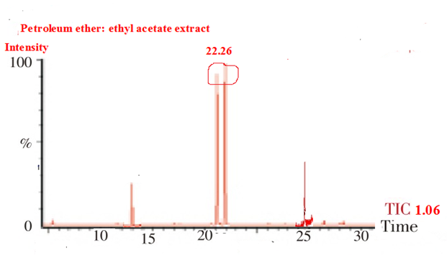

Figure 2: GC chromatogram of benzoic acid, 2-[(trimethylsilyl)-oxy]-methyl ester (cas) methyl o-trimethyl-silylsalicylate

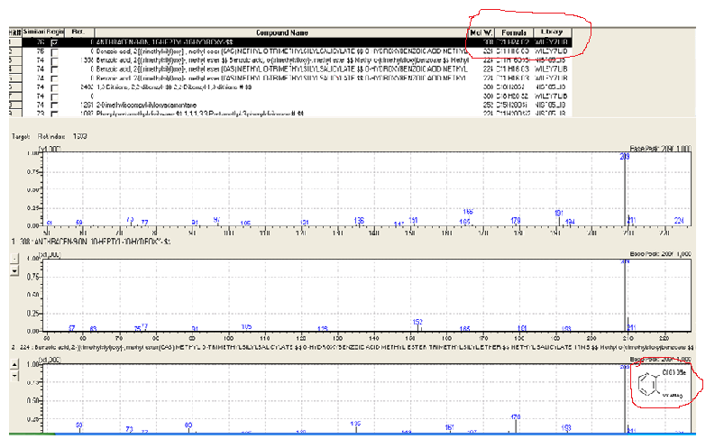
Figure 3: Molecular weight, formula and molecular structure of benzoic acid, 2-[(trimethylsilyl)-oxy]-, methyl ester (cas) methyl o-trimethyl-silylsalicylate

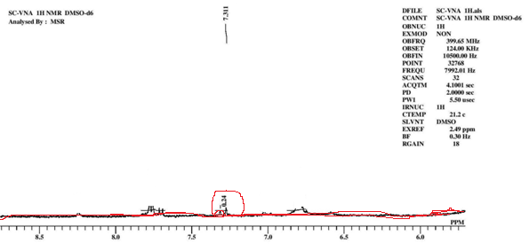
Figure 4: ¹ H NMR of fraction

